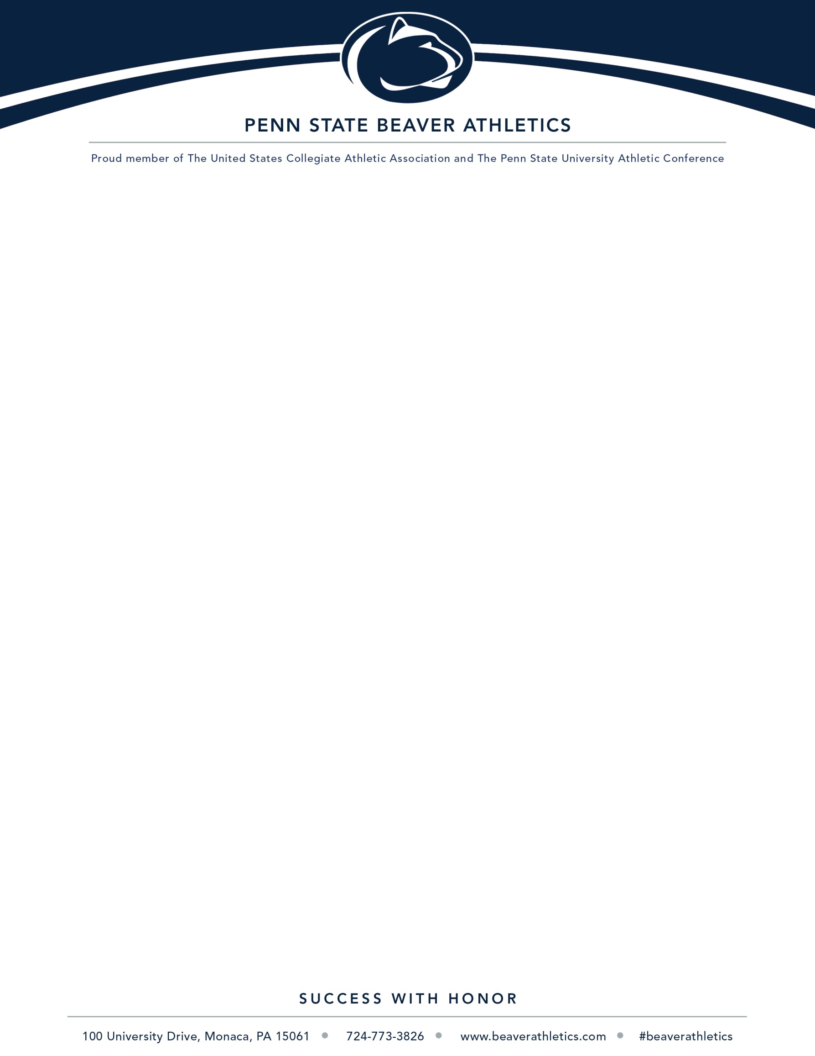

2021-22 Student-Athlete Contract
I understand that with being a student-athlete at Penn State Beaver comes expectations. I am expected to be a leader on campus among my student peers. I am here to better myself personally through education and athletically. I will strive my best both in the classroom and on the court/field.
- I agree to embody the Rise and Roar values of the department. I will Rise with honor through integrity and responsibility. I will roar with pride through respect, community, and excellence.
- I understand that on campus, in the community, and when traveling with the team, I am a representative of the University, and will represent Penn State Beaver to the best of my ability.
- I understand that hazing is not tolerated at Penn State Beaver. I pledge no matter the situation, I will not participate in acts that would be deemed hazing and will report any hazing that I witness.
- I understand there are academic eligibility requirements. I must pass 24 credits a year and maintain a 2.00 GPA or better. I also agree to attend the department study table program and will attend the hours required each week.
- I will adhere to the Penn State policy with excused class absents. I understand this process has moved online and can be submitted through the Penn State Beaver Athletic website.
- When injured, I agree to notify my coach, and work with the Athletic Trainer, Zoe Kratzer, to develop a treatment plan for my injury.
- I agree to abide by all wellness center rules and protocols. I will treat the Penn State Beaver staff with respect.

Finally, I understand that if I do not meet the outlined expectations above, there will be consequences.

Student-Athlete Signature | Date
Andrew C. Kirschner 8/16/21
Athletic Director Signature Date

